Huygens’ Principle:
Each point on a wavefront can be considered as a source of secondary wavelets (i.e., small waves). Each point on the initial wavefronts can be thought of as a point source producing circular waves. After one period, each of the individual circular waves will have advanced by a distance equal to one wavelength. When the amplitudes of each of the individual circular waves are added, the result is another plane wave that’s shown by a new wavefront. This process is repeated at the new wavefront, causing the wave to propagate in the same direction as the initial wavefront.
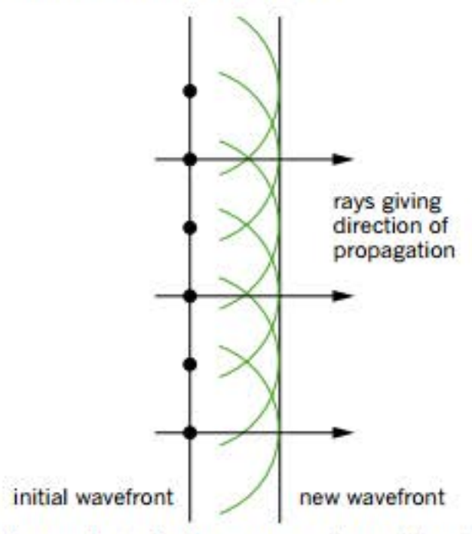
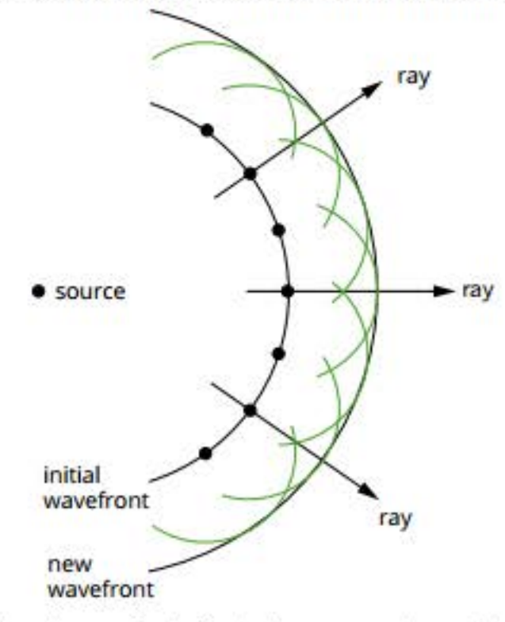
Reflection:
Can be explained using both a particle model and wave model.
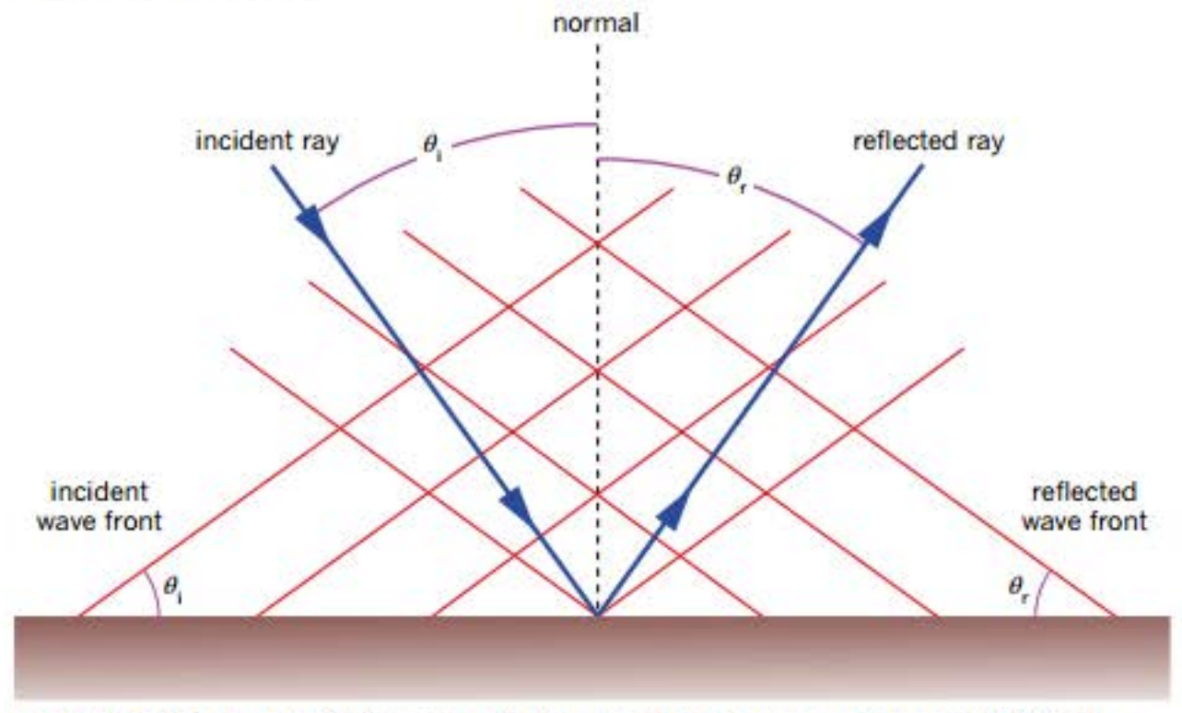
$$θ_{i}=θ_{r}$$
Refraction:
Refraction is the bending of a wave as its speed changes. A wave changes speed when it passes from one medium into another. Consider a wave moving from an incident medium where it has a higher speed (v₁) into a transmitting medium where it has a lower speed (v₂). For the same time interval that the wave travels a distance v₁t in the incident medium, it will travel a shorter distance v₂t in the transmitting medium. To do this, it must change direction (refract). When a wave changes its speed, its wavelength changes correspondingly but its frequency stays the same since there’s still the same number of waves per second. Waves can’t be gained or lost.
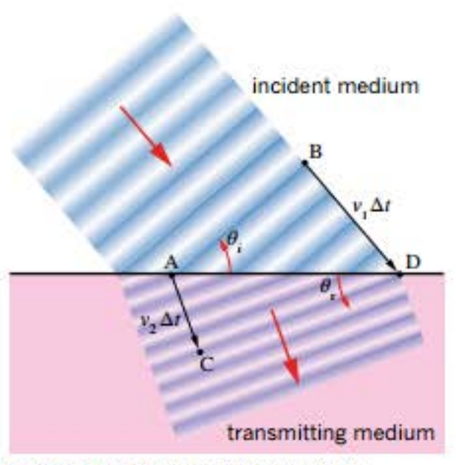
Refractive index (n):
The amount of refraction depends on how much the speed of light changes as light moves from one medium into another.
$$n=\frac{c}{v}$$
$$n_{1}v_{1}=n_{2}v_{2}$$
Snell’s Law:
$$n_{1}\sin{θ_{1}}=n_{2}\sin{θ_{2}}$$
$n_{1}v_{1}=n_{2}v_{2}$ and $n_{1}\sin{θ_{1}}=n_{2}\sin{θ_{2}}$ so refractive index is proportional to the angle.
If v₁ > v₂ then θ₁ > θ₂ and λ₁ > λ₂ and vice versa.

Total internal reflection:
When light passes from a medium with a high refractive index (low velocity) to one with a low refractive index (high velocity) it refracts away from the normal. As you increase the angle of incidence, the angle of refraction approaches 90 degrees. Eventually, at an incident angle called the critical angle, the angle of refraction is 90 degrees and the light is refracted along the interface between the 2 media. If the angle of incidence is increased above this value, the light is reflected back into the original medium as if it was striking a perfect mirror.
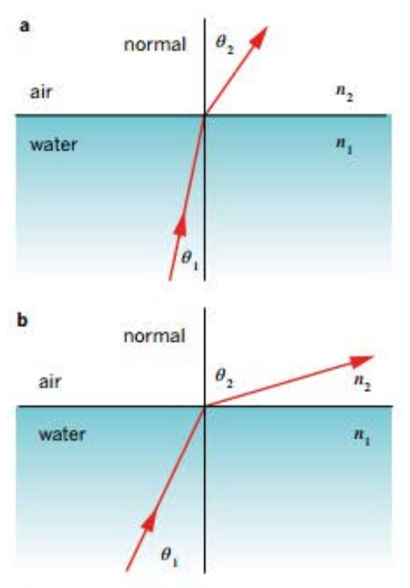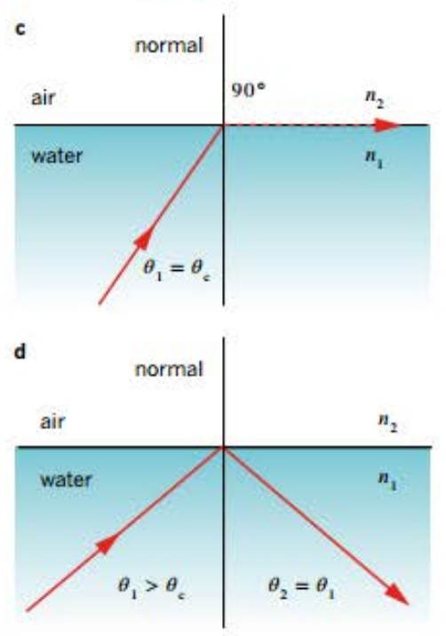
Dispersion:
Each colour of light represents a wave of a different wavelength. White light is a mixture of waves with many different wavelengths. When white light passes from one medium into another and slows down, its wavelength shortens as the wavefronts bunch up and the wavelength of each colour changes by different amounts. This means each colour is travelling at a different speed in the new medium and thus each colour is refracted by a different amount.
Longer wavelengths (e.g., those in red light) travel fastest in the new medium and thus are refracted less. Shorter wavelengths (e.g., those in violet light) travel slowest in the new medium and thus are refracted more. In effect, each colour has a different refractive index in a material.

Diffraction:
Diffraction is the bending of light has it passes through a gap or past an obstacle. It’s significant when the size of the wavelength of th wave is similar to or greater than the width of the gap or obstacle. Light waves range in wavelength from 400nm (violet light) to 700nm (red light).

Diffraction and slit width:
If the wavelength is smaller than the width of the gap or obstacle then the degree of diffraction is less. If the gap is much bigger than the wavelength then diffraction only occurs at the edges. Wavelengths comparable to or greater than the size of the gap or obstacle will produce signficant diffraction. This can be expressed as the ratio $\frac{λ}{w}$ ≥ 1 where w is the width of the gap or obstacle.

Diffraction and imaging:
Diffraction can result in blurred images when using microscopes or telescopes. Light from 2 tiny objects or 2 distant objects very close together can be diffracted so much that the 2 objects appear as one blurred object. When this happens the objects are said to be unresolved.
The ratio $\frac{λ}{w}$ dictates how small an object can be to be clearly imaged by a particular instrument. This means that, as a general rule of thumb, optical microscopes can’t generate images of objects that are smaller than the wavelength of the light they use since otherwise diffraction effects would be too significant.
The Hubble Space Telescope isn’t affected by atmospheric distortion. It can resolve images right down to its diffraction limit i.e., where the apparent separation of the stars is approximately equal to the wavelength of the light.

Diffraction gratings:
As light passes through a gap, some of the wavelets making up the wave diffract at the barriers making up the edges of the gap and some pass throught he centre. As a result, the wave emerging from the gap interacts. In some places the interactions will be constructive whilst in others destructive. When this light is made to shine on a screen, the areas of constructive interference will appear as bright bands and the areas of destructive interference will appear as dark bands. The pattern of bright and dark bands that’s seen when light is passed through a gap is called a diffraction pattern.
$\frac{λ}{w}$ is proprtional to the extent of diffraction of light and the width of the overall diffraction pattern.
Much clearer diffraction patterns can be seen by passing light through a diffraction grating – a piece of material containing many very closely spaced parallel gaps or slits. The diffraction pattern from one slit is superimposed on the pattern from the adjacent slit, producing a strong, clear image on the screen.

